**Integrated 3 MA LIMITS WS Name ________________________________________**

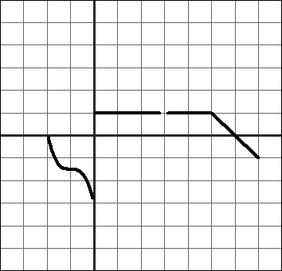**Based on the graph evaluate the following.**

**1.  = _____ 7.  = _____**

**2.  = _____ 8.  = _____**

**3.  = _____ 9.  = _____**

**4.** f(0) **= _____** **10.** f(6) **= _____**

**5.  = _____ 11.  = _____**

**6.** f(1) **= _____ 12.**  f(3) **= _____**

**13.  = _____ 14.  = _____**

**15.  = _____ 16.  = _____**

**17.  = _____ 18.  = _____**

**19.  = _____ 20.  = _____**

**21.  = _____ 22.  = _____**

**23.  = _____ 24.  = _____**