Name ________________________________________

Laws of Sines Applications

1. 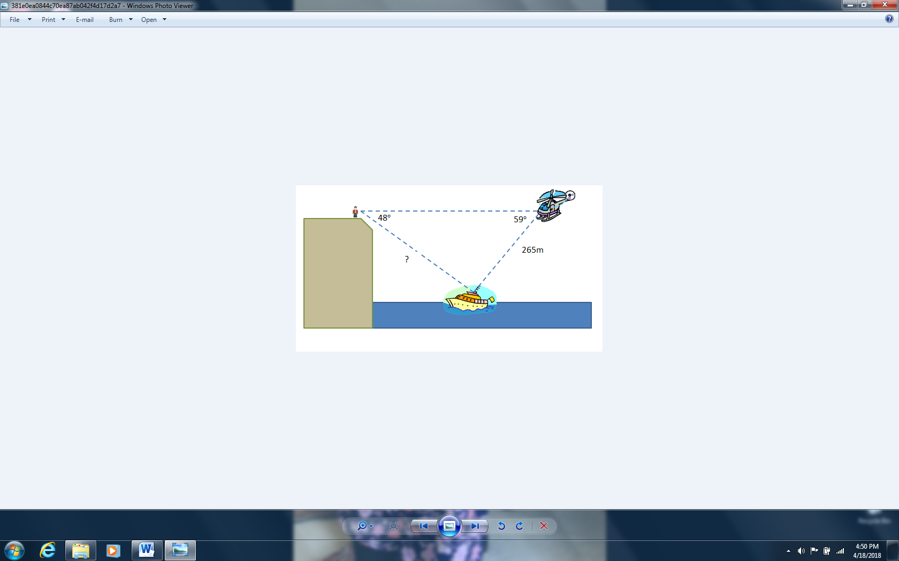A ship in trouble is sighted by both a man on the top of a cliff and by a coastguard helicopter. The angle of depression from the man to the ship is  and the angle of depression from the helicopter to the ship is . The helicopter is 265 meters from the ship. How far is the man from the ship?
2. Jacob and Natalie are standing on a river bank at points A and B respectively. Natalie is 130 meters from a house located across the river at point C. Suppose angle A is  and angle B is . How far are Jacob and Natalie standing from one another?
3. A hiker plans to hike up and down a mountain from one end to another in a straight path. The angle of elevation from the start point is  and from the end point is . The horizontal distance between the start and the end points is 19.06 miles. Find the total distance the hiker will travel.
4. A large helium balloon is tethered to the ground by two taut lines. One line is 100 feet long and makes an angle with the ground. The second line makes a angle with the ground. How long is the second line? How far apart are the tethers?