**INTEGRATED 3 - REVIEW SHEET FOR TEST** Name _______________________________

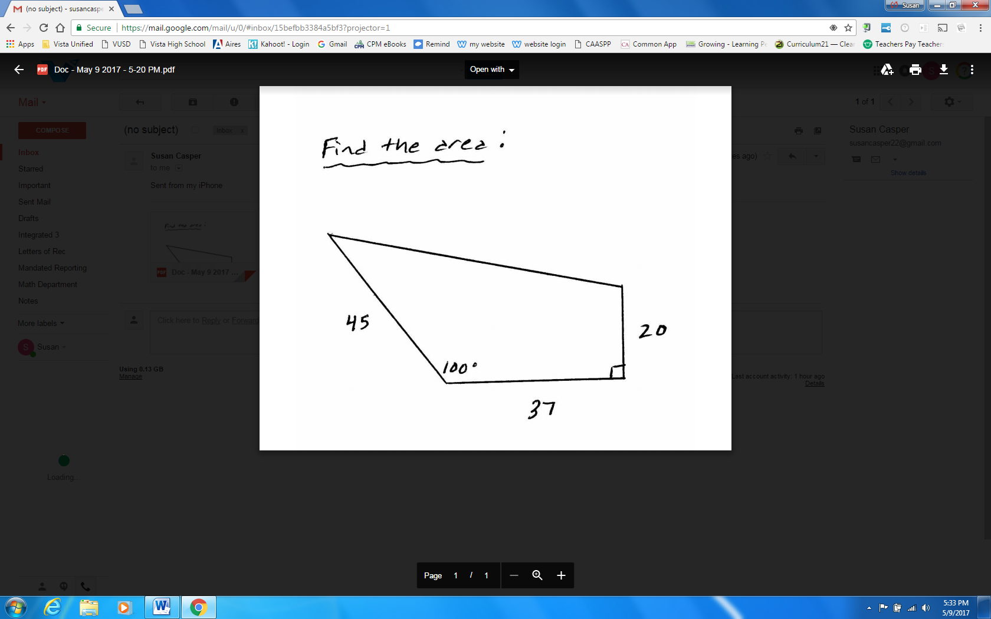1. Find the area of the quadrilateral shown.

2. Jack and Jill both start at point A. They each walk in a straight line at an angle of from eachother. After 1 hour, Jack has walked 5km and Jill has walked 6km. How far apart are they?

3. A 4m flagpole is not standing up straight. There is a wire attached to the top of the pole and anchored to the ground. The wire is 3.17m long. The wire makes a angle with the ground. What angle does the flagpole make with the ground?

4. Two observers are standing on a shore 500ft apart at points A and B. They measure the angle to a sailboat at point C.  measures  and  measures . Find the distance from the sailboat to each observer. Which observer is closer to the sailboat?