Integrated 3 Name_________________________________________

(Pg.56,61-62)

**2-7.**Determine the vertex of each of the following parabolas by averaging

the *x*‑intercepts.  Then write each function in graphing (vertex) form.

a.) 

b.) 

**2-18.**  FIRE!  CALL 9-1-1!

A fireboat in the harbor is helping put out a fire in a warehouse on the pier.  The

distance from the barrel (end) of the water cannon to the roof of the warehouse is

120 feet, and the water shoots up 50 feet above the barrel of the water cannon.

Sketch a graph and write an equation of the parabola that models the path of the water

from the fireboat to the fire.  State an appropriate domain and range for this situation.

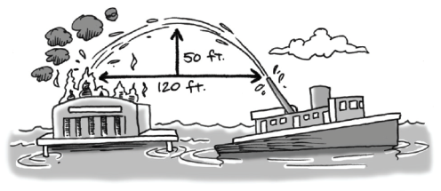

**2-21.**   Solve each of the following equations.  (leave your answers as fractions when applicable).

a.)  b.) 

c.)  d.) 