Integrated 3 – Chpt.1 Review (2) Name______________________________

1. Solve for : 

2. Given that  and 

a.) find 

b.) find  if 

c.) Arrange the functions so that the output of the first is the input of the second.

Find the final output if the beginning input is 2 in the order:  and then 

3. Solve by using the zero product property:

a.) 

b.) 

4. Solve by using quadratic formula: 

5. Find the domain and range:

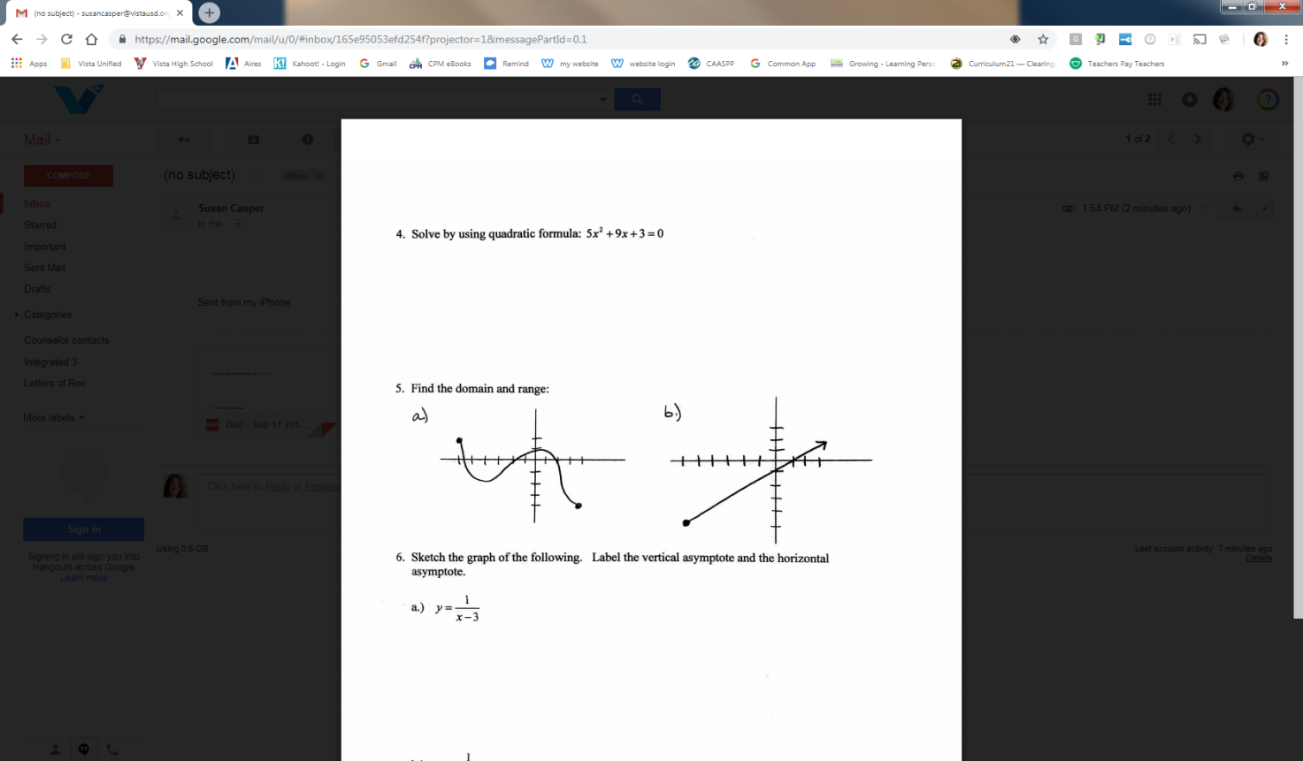

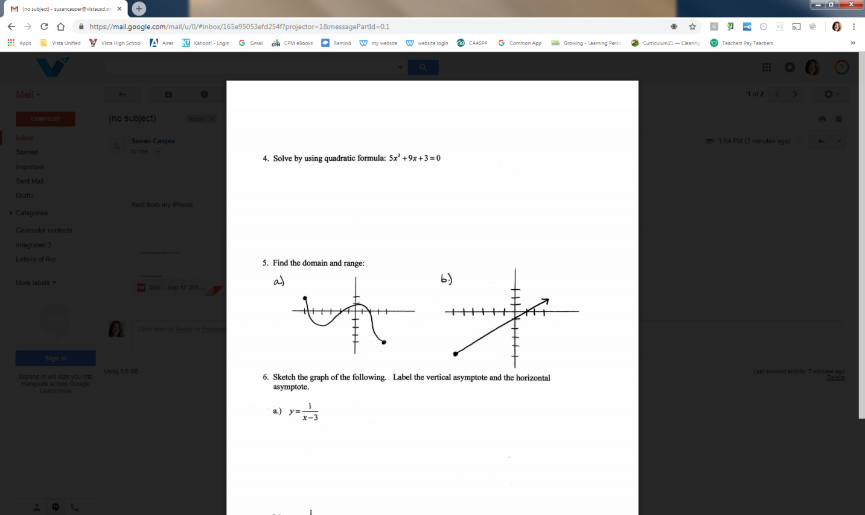 a.) b.)

6. Sketch the graph of the following. Label the vertical asymptote and the horizontal

asymptote.

a.) 

b.) 